Koby Samuel

iOS Application Development

10/28/15

Activity 1 for App 7

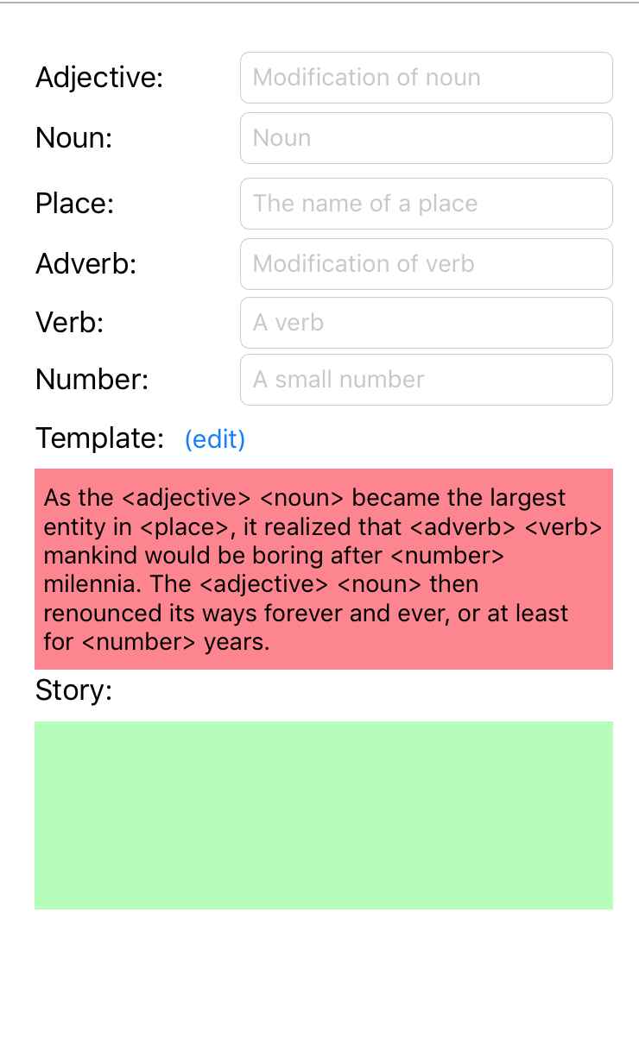

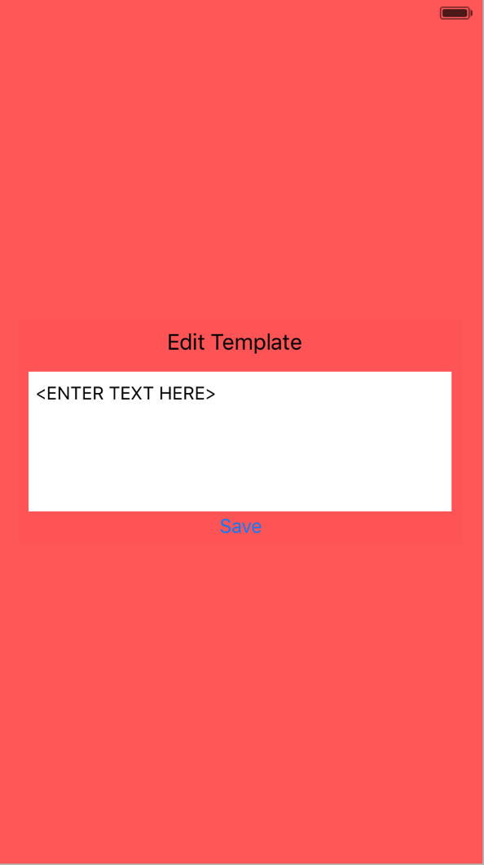

Button replaces original scene’s template text with edited text and redirects back to original scene

Editable text box populated by most current version of template

Button moves to new scene